Supermarket shopping – the hidden persuaders

Student: Class: Due date:

Think of shopping in a supermarket as a competition between the customer and the retailer. The retailer competes with you, the customer, by trying to transfer the money from your pocket into the cash register. It is   
a competition for your dollar. Successfully competing with the customer will guarantee the retailer sells more goods and ends up making larger profits. Supermarket retailers are experts at this type of competition. Subtle persuasion or even manipulation is all part of the game. To help win the game and get you to spend more in   
their stores, retailers use various ‘hidden persuaders’ — store features that attempt to influence the customer   
to buy.

**Instructions**

Look at the following sketch. In your notebook, explain how the feature shown at each numbered point might persuade supermarket customers to buy. Feature 1 has been completed for you.

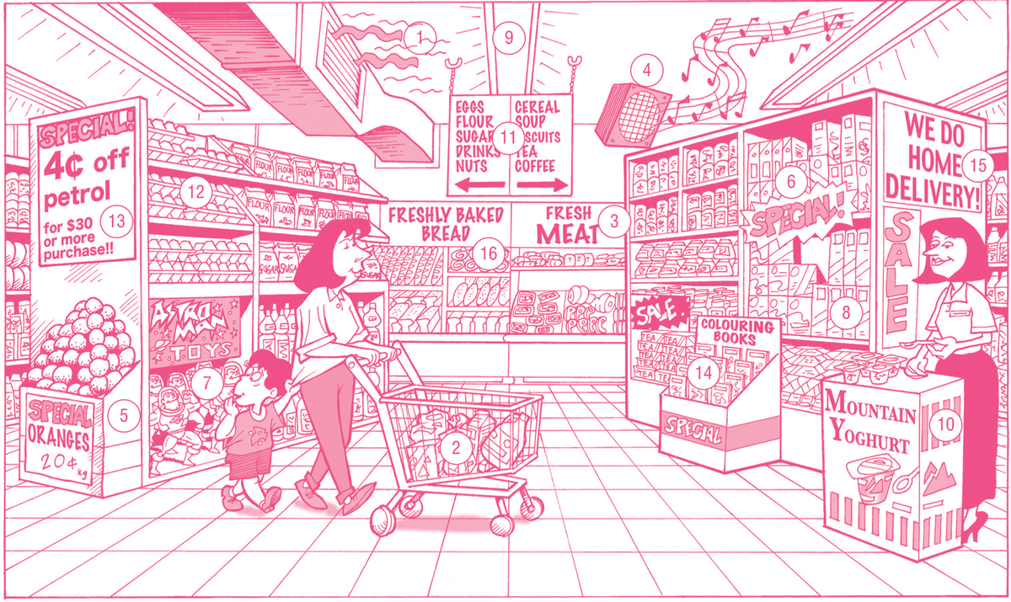

**Suggested answers**

| **Features** | **Explanation** |
| --- | --- |
| **1. Air-conditioning** |  |
| **2. Shopping trolleys** |  |
| **3. Essential items often located at the back  of the store** |  |
| **4. Music** |  |
| **5. End-of-aisle bins** |  |

|  |  |
| --- | --- |
| **Features** | Explanation |
| **6. ‘Sale’ and ‘special’ signs** |  |
| **7. Eye-catchers at children’s height** |  |
| **8. Bold, colourful display shelves** |  |
| **9. Bright lighting** |  |
| **10. In-store promotions** |  |
| **11. Elevated location signs** |  |

|  |  |
| --- | --- |
| Features | Explanation |
| **12. Shelves at an angle** |  |
| **13. Special offers** |  |
| **14. Mid-aisle bins** |  |
| **15. Home deliveries** |  |
| **16. Aroma of baking bread** |  |